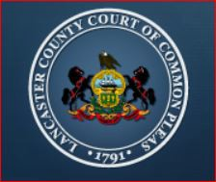
LANCASTER COUNTY COURT OF COMMON PLEAS
APPOINTMENT APPLICATION
YOUTH INTERVENTION CENTER BOARD OF MANAGERS

For consideration of a Court appointment, submit this application, along with your resume and letter of interest to: courtadmin@co.lancaster.pa.us no later than Friday, April 1, 2022, at 4:00pm. No phone calls or email inquiries will be entertained.
APPLICANT INFORMATION

FIRST NAME:
MI
LAST NAME

STREET ADDRESS:

CITY STATE ZIP CODE

DAYTIME PHONE # EVENING PHONE # ____________________________

EMAIL ADDRESS

Provide any relevant skills, experiences, certifications, expertise, interests, that may be helpful

List previous governmental and non-governmental boards on which you have served and/or currently serve.

NOTE: Current County / Court employees are not eligible to serve on this Board.

Signature Date

